

*#import the dataset and make some changes*

library(readr)

milk_production <- read_csv("C:/Users/bvkka/Desktop/ISL-Deep Medhi/assignment3/milk-production(1).csv")

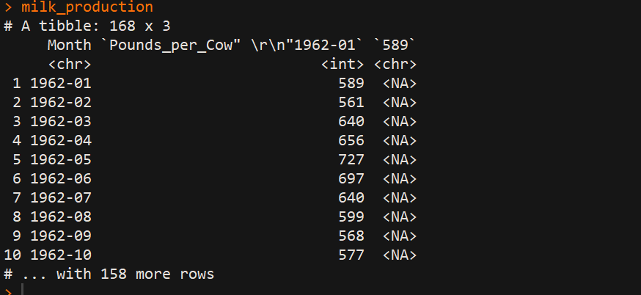

milk_production<-milk_production[,2]

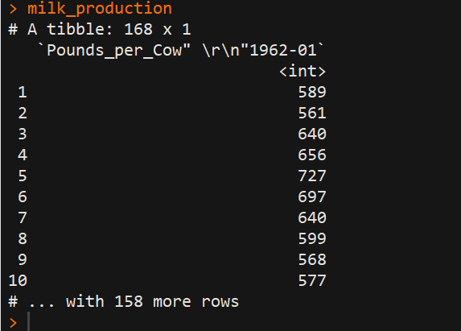

milk_production_timeseries<-ts(milk_production)

*#contains monthly milk productions for January 1970-Decemeber 1983*

mp_TS<-ts(milk_production,frequency = 12,start=c(1970,1))

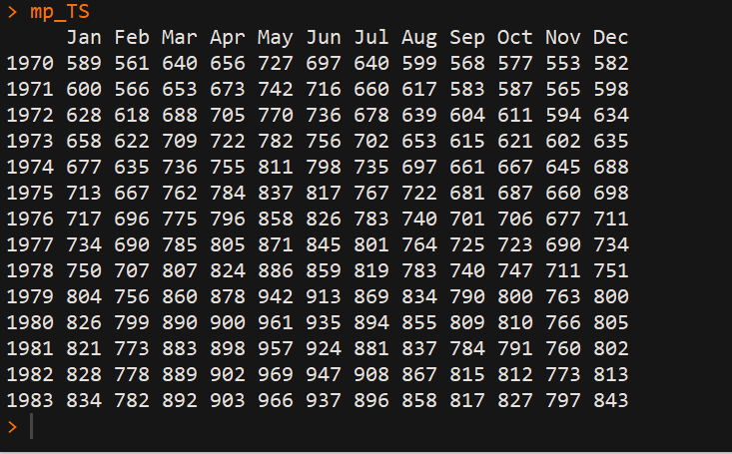

*#plotting time series*

plot.ts(milk_production_TS)

lines(mp_TS,col="blue")

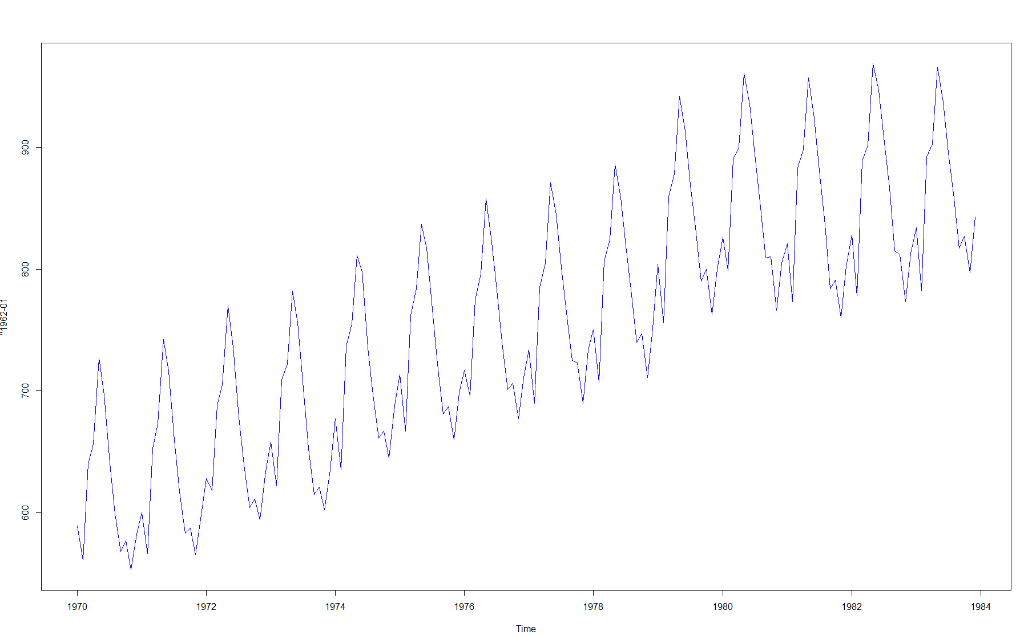

*## a. ##*

*#***Simple Moving Average(SMA)***# ->it is used to smooth time series data*

*#install.packages("TTR")*

library("TTR")

mp_TS3<-SMA(milk_production_TS,n=3)

plot.ts(mp_TS3)

lines(mp_TS3,col="purple")

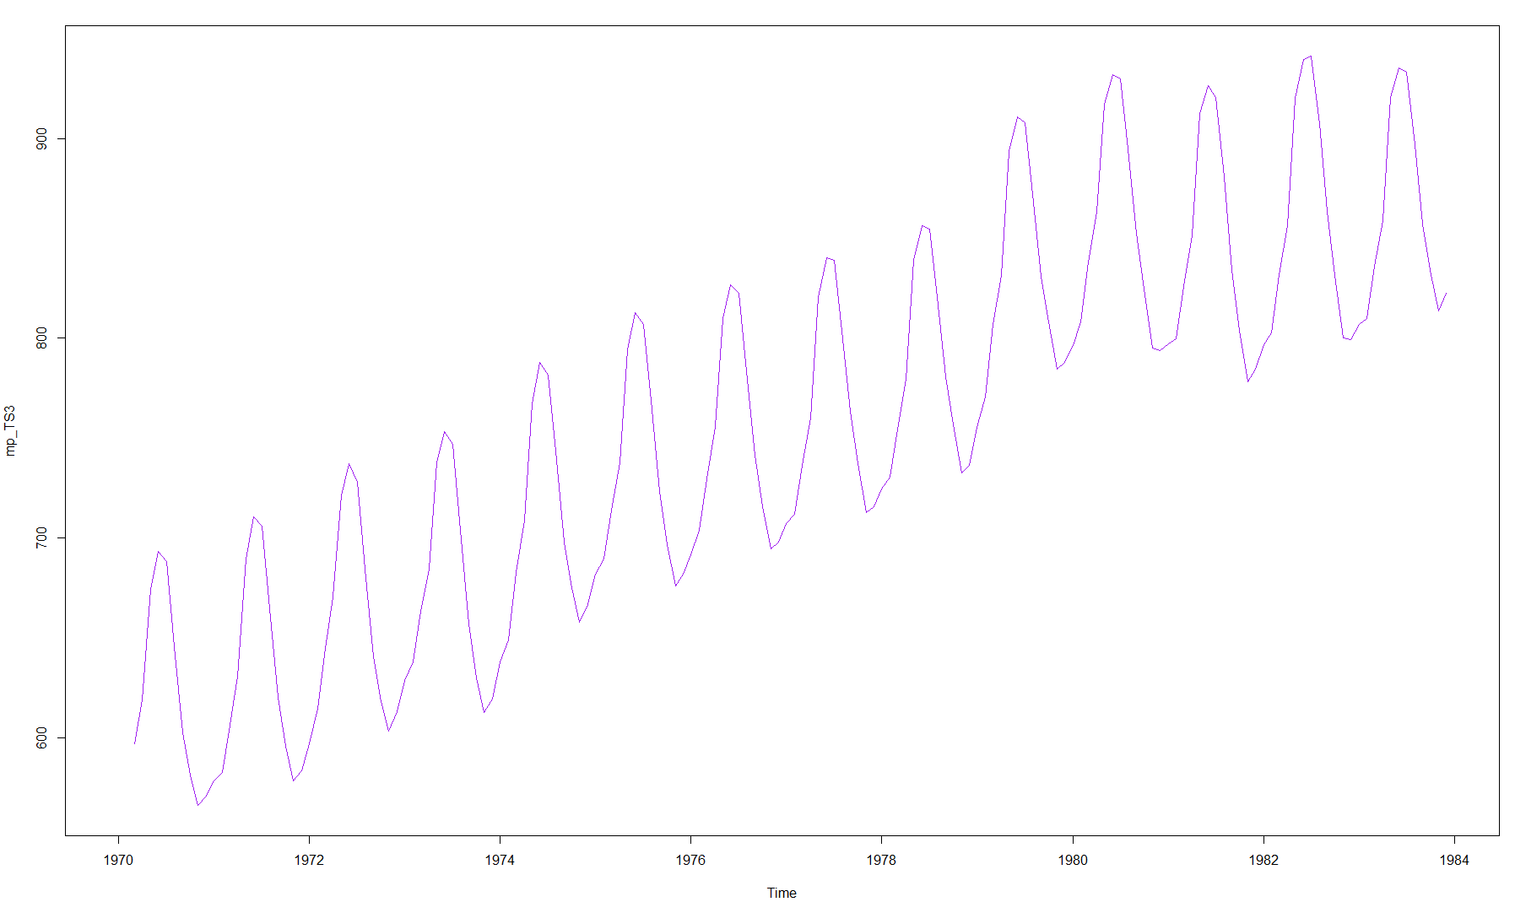

mp_TS5<-SMA(milk_production_TS,n=5)

plot.ts(mp_TS5)

lines(mp_TS5,col="red")

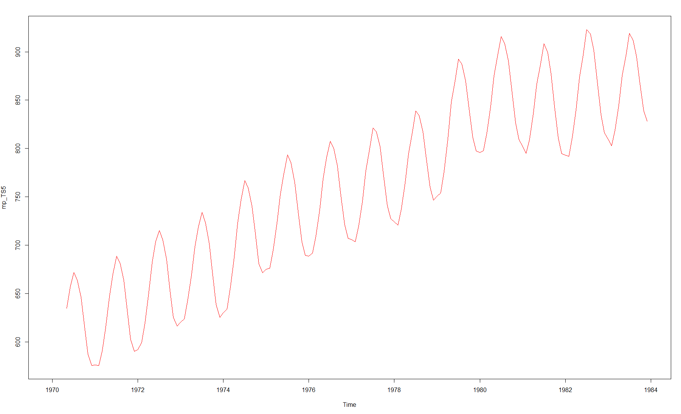

mp_TS8<-SMA(milk_production_TS,n=8)

plot.ts(mp_TS8)

lines(mp_TS5,col="green")

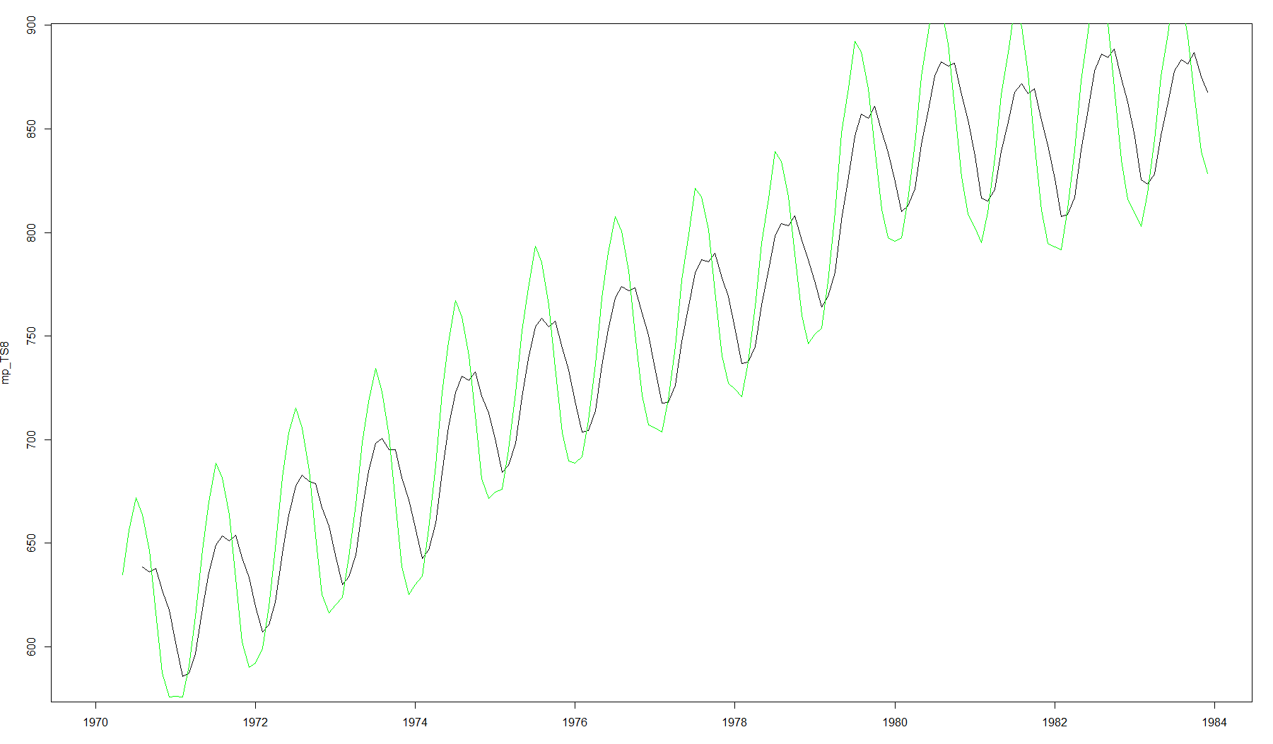

*#To estimate the trend component and seasonal component of a seasonal time series that can be described using an additive model, we can use the “decompose ()” function in R. This function estimates the trend, seasonal, and irregular components of a time series that can be described using an additive model###*

mp_decompose=decompose(milk_production_TS)

plot(mp_decompose) *#The plot above shows the original time series (top), the estimated trend component (second from top), the estimated seasonal component (third from top), and the estimated irregular component (bottom)##*

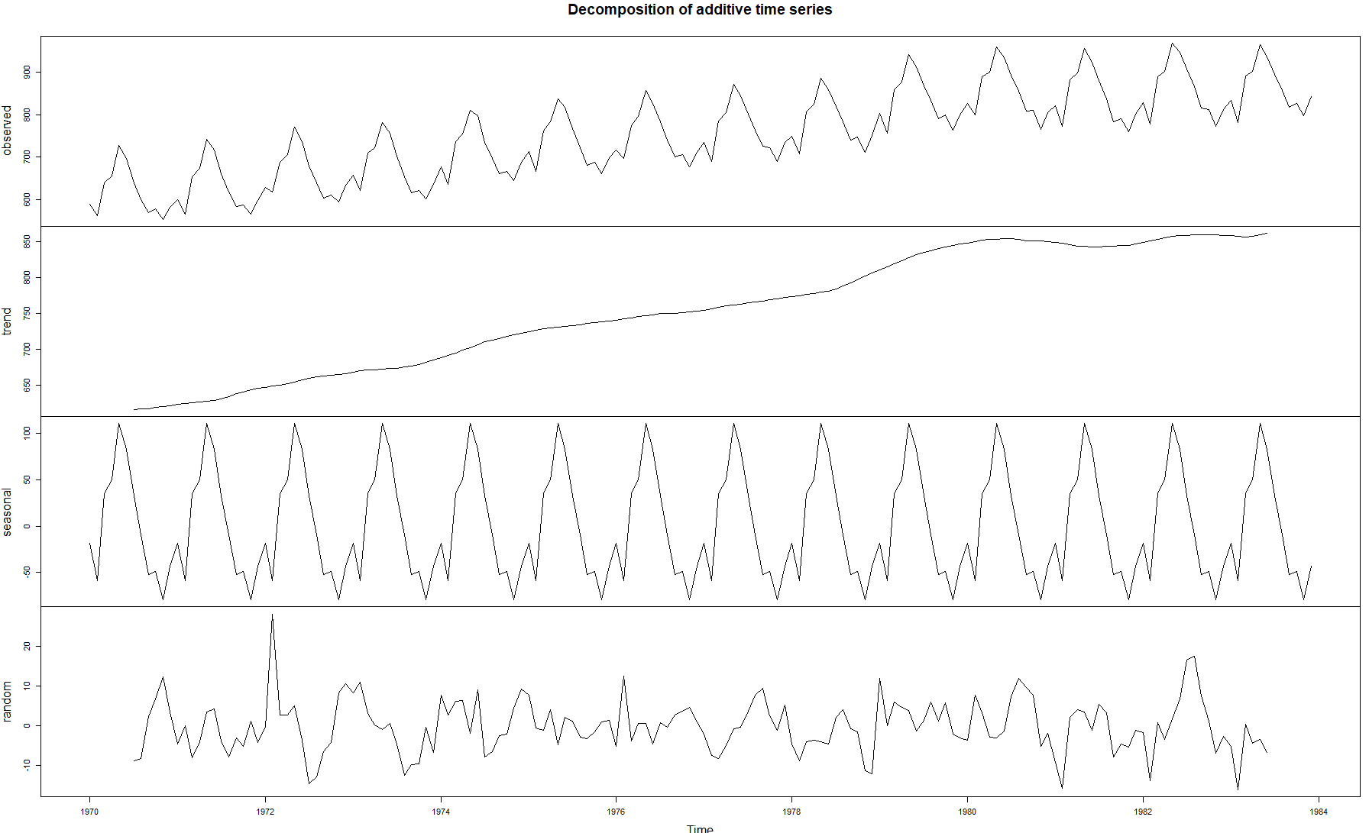

*## b. ##*

*#****Forecasts suing Exponential Smoothing***###*

mp_exp=HoltWinters(mp_TS,beta=FALSE,gamma = FALSE)

plot(mp_exp) *#The plot shows the original time series in black, and the forecasts as a red line. The time series of forecasts is much smoother than the time series of the original data here.*

lines(mp_exp$fitted[,1],col="red")

